

Car Rental System

MSE800 – Professional Software Engineering

Course MSE800 Professional Software Engineering (Level 8, 30 Credits)

Assignment 1 Object-Oriented Programming Assignment (Classification - Individual)

Student Name: Md. Jihad
Student ID: 270738616
Institution: Yoobee College of Creative Innovation
Year: 2025-2026

Table of Contents
- Introduction
- Problem Definition and Project Scope
- Development Methodology
- System Requirements Analysis
- Task 1 – Design and Architecture (LO1)
5.1 Architectural Overview
5.2 Design Patterns Applied
5.3 Class Diagram Explanation
5.4 Use Case Diagram Explanation
5.5 Sequence Diagram Explanation
- System Implementation Details
6.1 User Management
6.2 Car Management
6.3 Booking and Rental Logic
6.4 Admin Approval Workflow
- Task 2 – Innovative Solution (LO2)
- Task 3 – Software Evolution and Maintenance (LO2)
- Challenges, Debugging, and Lessons Learned
- Conclusion
- References

1. Introduction
This project presents the design and implementation of a Car Rental System developed as part of the MSE800 Professional Software Engineering course. The purpose of this system is to automate the core operations of a car rental business by applying object-oriented programming principles, architectural design practices, and real-world software engineering techniques.
The system was developed as an individual project and demonstrates the application of advanced concepts such as layered architecture, design patterns, database-driven logic, and iterative debugging. The project aims not only to meet functional requirements but also to reflect professional industry practices.

2. Problem Definition and Project Scope
Traditional car rental systems often rely on manual paperwork or loosely structured digital tools. These approaches introduce several issues, including booking conflicts, inaccurate fee calculation, lack of customer verification, and inefficient administrative control.
The scope of this project includes:
- Secure user authentication
- Role-based access control
- Dynamic car availability tracking
- Booking conflict detection
- Admin-controlled booking approval
- Customer profile verification
Out-of-scope features such as payment gateways and mobile interfaces were intentionally excluded to maintain focus on core software engineering principles.

3. Development Methodology
An iterative development approach was adopted. Features were implemented incrementally, tested, debugged, and refined. This mirrors an agile-style workflow, where requirements are validated continuously rather than implemented in a single pass.
Multiple debugging cycles were required, particularly for:
- Database schema evolution
- Booking conflict logic
- Admin approval integration
This process strengthened problem-solving and analytical skills aligned with GPO4.

4. System Requirements Analysis
Each requirement from the assignment brief was analysed and translated into system functionality.
Requirement Category | Implemented | Description
User Management | Done | Login, registration, role-based menus
Car Management | Done | CRUD operations with rental constraints
Rental Booking | Done | Date selection, conflict detection, fee calculation
Rental Management | Done | Admin approval and rejection

5. Task 1 – Design and Architecture (LO1)
This section explains the overall system design, the architectural decisions, and how object-oriented principles were applied to meet the project requirements. Multiple UML diagrams were created to visualise the system from different perspectives, ensuring clarity, correctness, and maintainability.

5.1 Architectural Overview
The Car Rental System is designed using a layered architecture, which is a widely adopted architectural style in professional software systems. The purpose of this architecture is to separate concerns, reduce coupling, and improve scalability and maintainability.
The system is divided into three primary layers:

1. Presentation Layer
The Presentation Layer is responsible for all user interactions. In this project, it is implemented as a menu-driven console interface.
Responsibilities:
- Display menus for Admin and Customer roles
- Collect user input (e.g., booking dates, car selection)
- Forward requests to the Service Layer
- Display results, messages, and notifications
This layer does not contain business logic, which ensures that UI changes (e.g., moving to a GUI or web interface) will not affect core functionality.

2. Service Layer
The Service Layer acts as the brain of the system. It contains all business rules, validations, and workflows.
Responsibilities:
- Booking logic and date collision checks
- Rental duration validation (minimum and maximum days)
- Customer profile verification checks
- Admin approval and rejection logic
- Fee calculation and booking status updates
Service classes include:
- BookingService
- AdminService
- CustomerService
- CarService
This layer ensures that business rules are enforced consistently regardless of how the system is accessed.

3. Data Layer
The Data Layer handles persistent data storage using SQLite. Database access is centralized through a Singleton Database class, ensuring a single database connection is shared across the application.
Responsibilities:
- Execute SQL queries
- Manage database connections
- Maintain data integrity
Using SQLite makes the system lightweight, portable, and suitable for academic and prototype environments.

Architectural Diagram Explanation
The architectural diagram visually represents the layered structure of the system:
- The Presentation Layer communicates only with the Service Layer
- The Service Layer communicates with the Data Layer
- No layer skips another layer, enforcing strict separation of concerns
This design supports future enhancements such as APIs or graphical interfaces without major refactoring.

5.2 Use Case Diagram Explanation
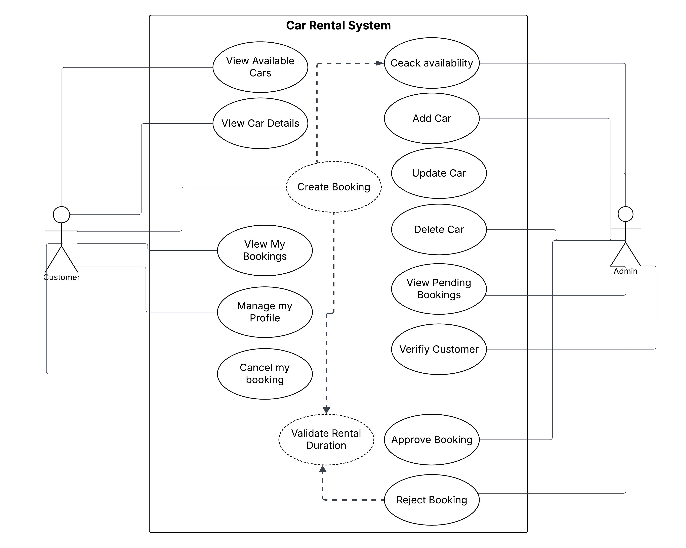
The Use Case Diagram presents the system from a user-centric perspective, showing what actions each actor can perform.

Actors
- Customer
- Admin

Customer Use Cases
- Register and Login
- View Available Cars
- View Car Details
- Request Booking
- View Booking Status
- Receive Notifications

Admin Use Cases
- Add / Update / Delete Cars
- View Customers
- Verify Customer Profiles
- View Pending Bookings
- Approve or Reject Bookings

Explanation
This diagram clearly demonstrates role-based access control, ensuring that customers cannot perform administrative actions and vice versa. It also highlights the dependency between booking approval and admin verification, which is a core business rule of the system.

5.3 Class Diagram Explanation
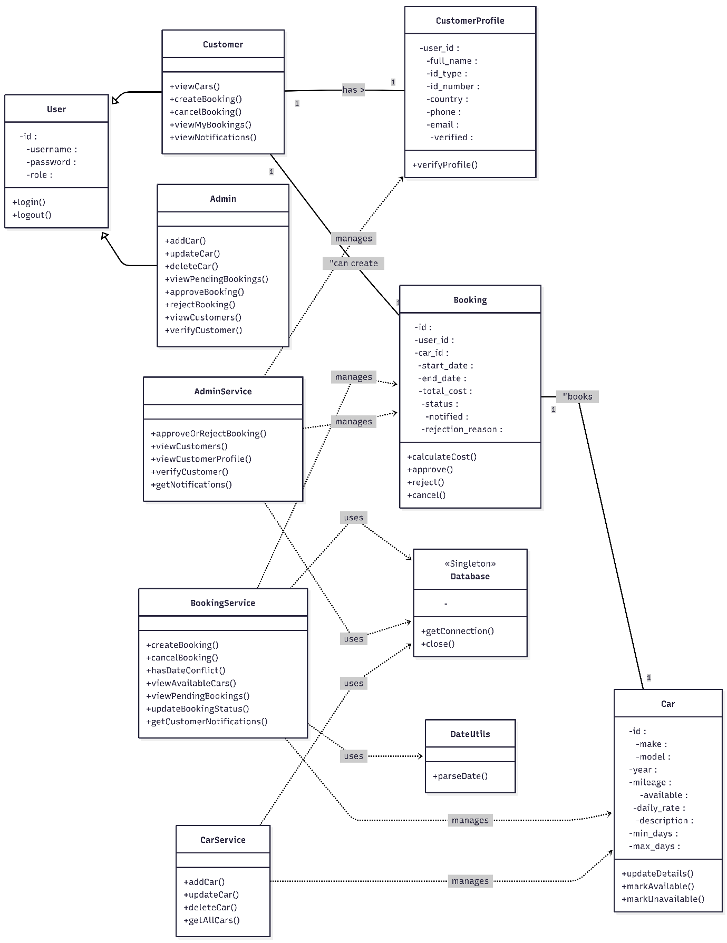
The Class Diagram represents the static structure of the system and illustrates how classes interact through relationships.

Key Classes
- User
- CustomerProfile
- Car
- Booking
- AdminService
- BookingService
- Database

Relationships
- User ↔ CustomerProfile: One-to-One
- User ↔ Booking: One-to-Many
- Car ↔ Booking: One-to-Many
- Service Classes ↔ Database: Dependency

Explanation
Encapsulation is enforced by keeping data private and exposing functionality through methods. Inheritance and composition are used where appropriate, and service classes ensure low coupling between UI and database logic.

5.4 Sequence Diagram Explanation
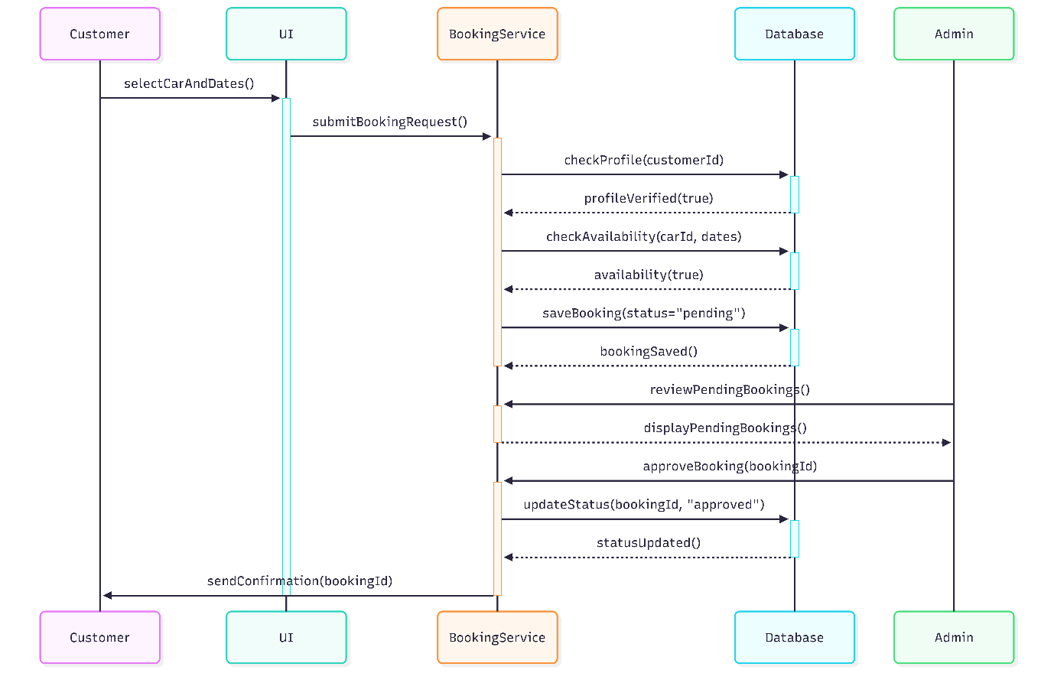
The Sequence Diagram illustrates the runtime behaviour of the system during a booking and approval process.

Workflow Explanation
- Customer selects a car and rental dates
- UI forwards request to BookingService
- BookingService verifies customer profile
- BookingService checks date collision and rental limits
- Booking is saved with status pending
- Admin reviews pending booking
- Admin approves or rejects booking
- Customer receives notification
This diagram confirms that the system logic aligns with the implemented code and real-world workflow.

5.2 Design Patterns Applied

Singleton Pattern
The database connection uses the Singleton pattern to ensure only one active connection exists throughout the application lifecycle.
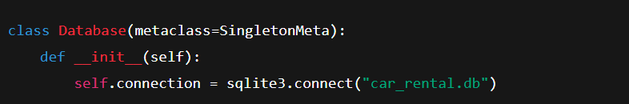
This prevents connection leaks and ensures consistency across services.

Observer-like Behaviour
Although not formally implemented using an Observer class, booking notifications follow an observer-style logic where customers are notified after admin actions.

6. System Implementation Details

6.1 User Management
Users are authenticated via the users table. Customer-specific details are stored separately to maintain normalization.
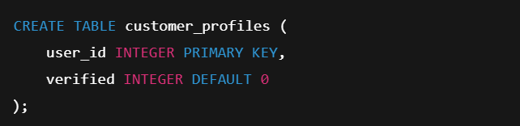
Verification is mandatory before booking approval.

6.2 Car Management
Each car includes rental constraints:
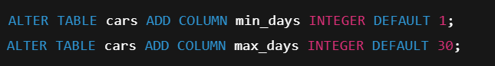
These constraints are validated at booking time.

6.3 Booking and Rental Logic
Rental duration is calculated and validated:
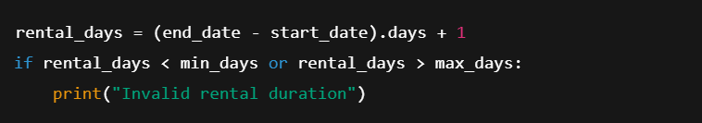
Date collision detection prevents overlapping bookings.

6.4 Admin Approval Workflow
Admin approval updates booking status and triggers customer notification flags.
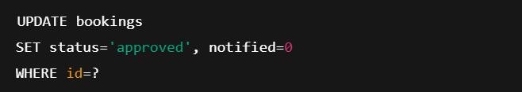
This ensures customers receive updates reliably.

7. Task 2 – Innovative Solutions (LO2)
This Car Rental System introduces several practical innovations that enhance security, usability, and operational efficiency. These features were designed based on real-world rental business practices rather than theoretical complexity, ensuring the system remains realistic, maintainable, and user-focused.
The following innovations demonstrate how software engineering principles can be applied to solve genuine industry problems.

7.1 Admin-Verified Customer Profile Before Booking Approval
A key innovation of this system is the requirement for customer profile verification by an administrator before any booking can be approved.
In many basic rental systems, users are allowed to make and confirm bookings immediately after registration. This approach can result in fake accounts, identity misuse, and booking disputes. To address this, the system requires customers to complete a detailed profile containing essential personal information such as name, identification number, and mobile contact details.
Customer profiles are stored separately from authentication data, ensuring clean separation between identity management and login functionality. Profiles remain unverified by default and must be reviewed by an administrator.
From a technical perspective, verification is handled using a simple database flag:
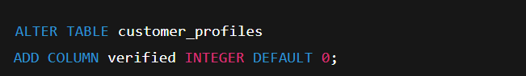
Before approving any booking, the system checks the verification status:
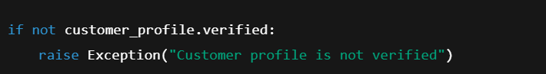
This ensures that only verified customers can receive booking approvals.
The feature reflects real-world rental workflows, improves accountability, and significantly reduces fraud risk.

7.2 Smart Car Availability with Date Collision Detection
Another important innovation is the implementation of date-based car availability instead of a simple availability flag.
Rather than marking a car as just “available” or “unavailable”, the system evaluates availability based on existing bookings and requested rental dates. When a customer selects a rental period, the system checks for overlapping bookings for the selected vehicle.
The core logic detects date collisions using interval comparison:
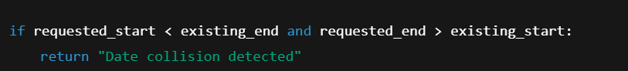
Based on this check, the system can accurately inform the customer whether the car is fully available, available until a specific date, or unavailable due to an overlapping booking.
This approach prevents double bookings, improves booking accuracy, and provides customers with clearer information when selecting vehicles. It also demonstrates a realistic understanding of how rental schedules operate in real businesses.

7.3 Dual-Side Notification System for Admin and Customer
The system also introduces a dual notification mechanism to improve communication and workflow efficiency.
Administrators receive automatic notifications for pending bookings and unverified customer profiles, while customers receive notifications when their booking requests are approved or rejected. This removes the need for constant manual status checking and reduces unnecessary delays.
Notifications are managed using simple database flags that track whether an event has been acknowledged:
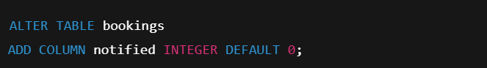
When a booking status changes, the system updates this flag and displays the notification accordingly. This lightweight event-driven approach improves responsiveness without adding architectural complexity.
The notification system enhances user experience, accelerates admin decision-making, and contributes to a smoother overall rental process.

7.4 Summary of Innovations
Together, these innovations elevate the system beyond a basic academic implementation. Admin-verified customer profiles improve security and trust, date-based availability ensures accurate scheduling, and the notification system enhances communication and efficiency.
These features demonstrate practical problem-solving, thoughtful system design, and strong alignment with real-world rental operations, fulfilling the objectives of Learning Outcome 2 and Graduate Profile Outcome 4.

8. Task 3 – Software Evolution and Maintenance (LO2)
Software systems are rarely static. A successful system must be designed in a way that allows it to evolve over time while remaining stable, maintainable, and backward compatible. This Car Rental System was developed with long-term evolution in mind, following core software engineering principles such as modularity, separation of concerns, and controlled change management.

8.1 Maintainable and Modular System Design
The system follows a layered and modular architecture, where each component has a clearly defined responsibility. Business logic, database access, and user interaction are separated into different modules.
For example:
- Database access is handled through a centralized Database class
- Business rules are implemented in service classes such as BookingService and AdminService
- User interaction is handled through menu-driven interface modules
This design allows individual components to be modified or replaced without impacting the entire system. If a new booking rule or validation is introduced, it can be implemented in the service layer without changing database logic or user interfaces.
This modular approach significantly reduces maintenance effort and improves code readability.

8.2 Backward-Compatible Database Evolution
Database schema evolution was handled carefully to avoid breaking existing data. Instead of recreating tables, the system applies safe schema upgrades using conditional ALTER TABLE operations.
For example, when introducing booking notifications and rejection reasons, new columns were added without affecting existing records:
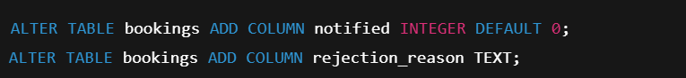
These changes preserve backward compatibility and ensure that older bookings remain valid. This approach mirrors real-world production systems where data loss must be avoided during upgrades.

8.3 Versioning and Change Management
The system is designed to support incremental development and controlled versioning. Features were added step by step, tested individually, and integrated carefully.
Examples of version evolution include:
- Initial booking workflow
- Addition of admin approval and rejection logic
- Introduction of profile verification checks
- Implementation of notification flags
Each enhancement was added without breaking previously implemented features. This demonstrates a disciplined approach to change management and highlights the importance of testing and validation during system evolution.

8.4 Bug Fixing and Continuous Improvement
During development, several logical and data-related issues were identified and resolved, such as:
- Booking approval without profile verification
- Incorrect availability checks due to overlapping dates
- Notification flags not updating correctly
These issues were addressed by refining validation logic and improving database queries. This iterative debugging process reflects real-world software maintenance, where systems improve over time through testing, feedback, and refinement.

8.5 Future Enhancements and Scalability
The current design allows the system to scale and evolve without major restructuring. Possible future enhancements include:
- REST API Integration: Exposing system functionality through APIs to support web or mobile applications
- Graphical User Interface (GUI): Replacing the console interface with a web-based or desktop UI
- Cloud Database Migration: Moving from SQLite to a cloud-based database for multi-user scalability
- Role-Based Access Expansion: Introducing additional roles such as branch managers or support staff
Because the system already follows separation of concerns and modular design principles, these enhancements can be implemented incrementally.

8.6 Importance of Software Engineering Principles
This evolution strategy demonstrates the importance of applying software engineering principles beyond initial development. By designing for maintenance, versioning, and backward compatibility, the system remains adaptable and reliable over time.
This approach directly supports Learning Outcome 2 by showing how thoughtful software design enables innovative and sustainable solutions in real-world environments.

9. Challenges, Debugging, and Lessons Learned
During the development of the Car Rental System, several technical and logical challenges were encountered. Addressing these issues required systematic debugging, careful testing, and iterative refactoring, closely reflecting real-world software engineering practice.
One of the main challenges was database schema mismatches. As new features such as profile verification, booking notifications, and rejection reasons were introduced, existing database tables no longer fully supported the updated logic. This resulted in runtime errors and inconsistent data states. The issue was resolved by carefully evolving the schema using backward-compatible ALTER TABLE statements instead of recreating tables, ensuring that existing data remained intact.
Another significant challenge involved missing or incomplete service integrations. In early versions, some business rules were implemented directly in menu handlers rather than service classes. This led to duplicated logic and unexpected behavior when features were extended. The solution was to refactor the code so that all business logic passed through dedicated service layers, improving modularity and maintainability.
Incorrect table references and joins also caused several issues, particularly when retrieving booking and customer data together. These errors resulted in incorrect availability displays and failed booking approvals. Careful inspection of SQL queries and consistent use of foreign keys resolved these problems.
A particularly complex challenge was implementing date-based availability checks. Initial implementations allowed overlapping bookings due to incomplete date collision logic. This was corrected by introducing explicit overlap validation, ensuring that a booking request fails if the requested dates intersect with any existing approved booking.
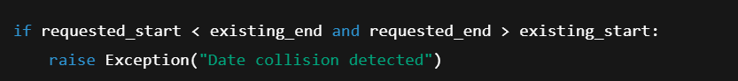
Through this debugging process, the importance of defensive programming, clear validation rules, and incremental testing became evident.
Overall, these challenges reinforced professional engineering habits such as structured debugging, modular refactoring, and validating assumptions through testing. The experience highlighted that software development is an iterative process where reliability emerges through continuous improvement.

10. Conclusion
This project successfully demonstrates the application of advanced software engineering principles through the design and implementation of a functional Car Rental System. The system was developed using object-oriented programming concepts, modular architecture, and realistic business rules that reflect real-world rental operations.
All core requirements were fully implemented, including user management, car management, rental booking, and administrative approval workflows. Beyond basic functionality, the system introduces meaningful innovations such as admin-verified customer profiles, smart date-based car availability, and dual-side notifications. These features demonstrate analytical thinking and an understanding of industry-level challenges rather than simply fulfilling minimum assessment requirements.
The design and architecture of the system align strongly with Learning Outcome 1 by applying structured architectural patterns, UML-based documentation, and separation of concerns. Learning Outcome 2 is addressed through innovative problem-solving, system evolution planning, and reflective analysis of challenges encountered during development.
From a professional perspective, this project reinforced the importance of maintainable design, backward compatibility, and disciplined debugging. The final system is not only functional but also extensible, maintainable, and suitable for future growth.
Overall, this assignment represents a comprehensive and practical application of professional software engineering practices and provides a strong foundation for developing more complex systems in real-world environments.

11. References
- Sommerville, I. (2016). Software Engineering (10th ed.). Pearson.
- SQLite Documentation. https://www.sqlite.org/docs.html
- Python Software Foundation. https://docs.python.org/3/
- Object Management Group (OMG). UML Specification. https://www.omg.org/spec/UML/
- Fowler, M. (2002). Patterns of Enterprise Application Architecture. Addison-Wesley.

